**Finding the MSUE Organizational Development (OD) Website**

Go to the MSUE home page at [www.msue.msu.edu](http://www.msue.msu.edu) and then hover over Michigan State University Extension in the top, gray bar:

cid:image001.png@01CF0C69.995F4210

A drop down menu will appear. Select “Organizational Development”.

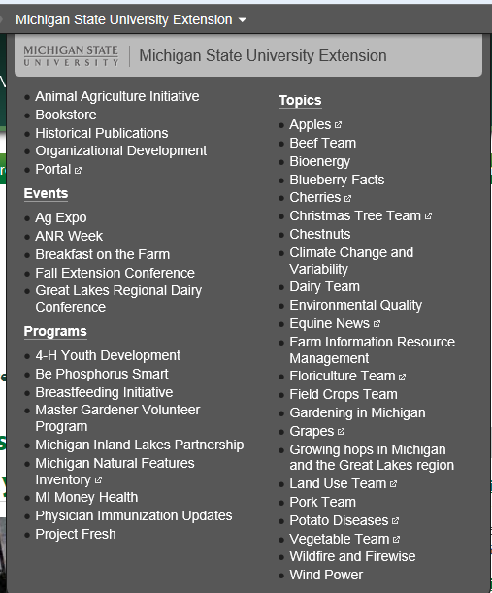

Our web site includes links to all of the OD units and more! See the left, purple, column:

